# Bot Agent log files

* Various types of information about the Bot Agent are captured in different log files. You can analyze these log files when the Bot Agent or a bot encounters an error and identify the root cause for that error.

**The Bot Agent log files enable you to perform these actions:**

* Determine whether a bot ran successfully
* Identify issues that resulted in a bot failure
* Determine if the device is properly connected with the Control Room

## Log file locations

The Bot Agent log files are available at **C:\ProgramData\AutomationAnywhere\BotRunner\Logs on your device**. The following files are available at this location:

**Bot_Launcher**

Captures information about the execution of a bot such as the operations performed, events triggered, and errors encountered by the bot.

The filename now includes the name of the user running the bot on the Bot Runner. For a multi-user session machine, there will be a bot launcher log per user.

**Node_Manager**

Captures information about when a bot is run from the Control Room and communication details between a Bot Runner and the Control Room.

## Log file configuration

**To configure the different types of log files that can be collected from the devices connected to the Control Room,**

The log collection configuration enables you to collect log entries from the devices connected to the Control Room.

You can view the system log information on your device at the following locations:

* Bot Agent installed as admin user: C:\ProgramData\AutomationAnywhere\BotRunner\Logs
* Bot Agent installed as local user or non-admin user: %userprofile%\AppData\Local\AutomationAnywhere\BotRunner\Logs

.

The following logs are collected:

* Node manager logs
* Bot launcher logs
* Browser extension logs

**Note:** Starting from Automation 360 v.29 (Cloud), all the Bot Agent logs are retrieved and stored in the Amazon Simple Storage Service (Amazon S3) by default for all instances. This is only applicable to the Amazon Web Services (AWS). The Bot Agent logs are collected at a regular interval and might result in the slowness of Control Room.

Although a Control Room administrator can disable the log collection functionality, it is not available as part of the standard Automation 360 Cloud. Contact your Automation Anywhere Customer Success Manager (CSM) for assistance.

You can choose to collect one of the following log-level information:

**Note:** In the production (**PROD**) environment, we recommend that you set the log file configuration level to **INFO** for optimal performance.

* **Info (default):** Informational messages that highlight the progress of the application
* **Debug:** Fine-grained information that is useful for debugging an application
* **Trace:** Captures every behavior of the application in detail

## Procedure

1. Navigate to **Administration** > **Settings** > **Devices**.
2. Click **Edit** in the **Log collection configuration** tab.
3. To configure the level of log collection, select one of the following::
   * **Info** - to get informational messages that highlight the progress of the application.
   * **Debug** - to get detailed information that are useful for debugging an application
   * **Trace** - to capture the application behavior in detail.
4. Set the maximum log file size between 1 MB and 100 MB.
5. Set the maximum number of log files between 1 and 500.
6. Save the settings.

 it was showing my device as disconnected and it keeps fluctuating.

To overcome this issue, I tried to reinstall the Bot Agent, but it didn't worked.

Finally I came across the root cause of the issue i.e. file "registration.properties" is missing in AutomationAnywhere folder on the path C:\Windows\System32\config\systemprofile\AppData\Local. I tried to delete the existing AutomationAnywhere folder from the mentioned path and tried to reinstall the Bot Agent, so AutomationAnywhere folder got recreated again automatically but it has only 3 files in it instead of 4,the file "registration.properties" is still missing.

So can anyone please suggest how can I get this file "registration.properties" again, as this file is missing and not allowing to execute any of the bot in my system. Please suggest.

**Solution:**

"registration.properties" file gets created, when bot agent registers with control room.

Only installing the agent doesn't create the file.

Refer to below screenshot, which is taken right after installing bot agent.

So, I am assuming that, in your agent machine, agent is installed, but you still have to follow the registration process.

1) If your agent machine is/was registered previously, then go to Control Room web portal -> Manage -> Devices -> Delete the device.

2) To add the device again,

* **On your agent machine**, where agent is installed, launch Control Room web portal.
* Login with **Bot Runner user**.
* Try registering/adding the device by clicking "Connect Local Device" button, as shown in screenshot below.

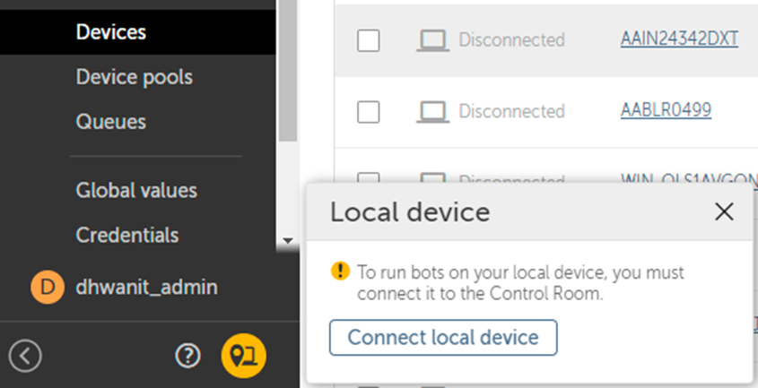

* Once device is registered successfully, you should see the registration.properties file created.
* Device status will also show as "Connected"
* 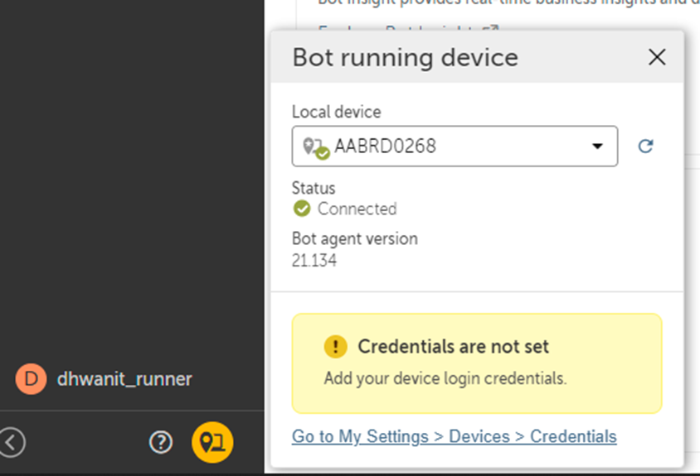
* Node_Manager. Captures information about when a bot is run from the Control Room and communication details between a Bot Runner and the Control Room.

Issue occuring with bot execution. While we start to run the bot we get the error "Device Error, if problem exists contact your system administrator" This issue started to occur from today

**Please check the NodeManager.logs :** C:\ProgramData\AutomationAnywhere\BotRunner\Logs\Node_Manager.log you should be able to identify the cause of the issue.

**Issue was:** Proxy was blocking the download of package from server to local. Checked it in NodeManager.logs.

**Resolution**: I has to reset the proxy and the BOT was able to download the relevant packages and execute the BOT.

# **Bot fails with "fetch global values failed" error**

**Problem**

Running IBM RPA with Automation Anywhere v19, the Bot fails with the following error:

2021-Sep.-08 Mi. 12:50:32.717 ERROR - com.automationanywhere.botrunner.bot.Bot_Content {deploymentId=6f6cb991-054f-43f0-9a34-a505ec7e27df_845383eea7900cef, traceId=845383eea7900cef} - handleThrowable(Bot_Content.java:3745) - bot status 'FAILED' updated com.automationanywhere.botcommand.exception.BotCommandException: fetch global values failed

at com.automationanywhere.toolchain.runtime.util.GlobalValueHelper.fetchGlobalValues(GlobalValueHelper.java:42) ~[bot-runtime.jar:?]

**Symptom**

Bot fails with this error after 20 minutes.

**Cause**

This error is faced as a result of the error:

ERROR- com.automationanywhere.refresh.token.TokenRefreshServiceImpl {} -

onFailedRefreshAttempt(TokenRefreshServiceImpl.java:151) - attempt 1

refresh failure java.lang.RuntimeException: Unexpected error refreshing

user token

This error is observed when the bot agent is unable to communicate with the control room with the registered user details.

**Resolving The Problem**

The following steps can help to resolve the issue:

1. Stop the bot agent service.
2. Clear the global cache folder. You can find GlobalCache folder in C:\ProgramData\AutomationAnywhere on Bot runner machine.
3. Rename registration.properties file from location C:\Windows\System32\config\systemprofile\AppData\Local\AutomationAnywhere. File gets re-created when the bot agent service starts.
4. Start the bot agent service.

The Bot should run as expected

How do you fix a null pointer exception?

NullPointerException is thrown when a reference variable is accessed (or de-referenced) and is not pointing to any object.

Solution :

This error can be resolved by using a try-catch block or an if-else condition to check if a reference variable is null before dereferencing it.

**The customer is unable to pass the variable from the child bot to the Parent bot, throwing "Null pointer Exception" in the Message Box.**

**Cause**

The variable in the If condition has the NULL value defined

**Resolution/Workaround**

Make sure that the value in the variable of any condition or command should not be having a NULL value within the child bot or parent bot.   
Some values should be defined for the variable within the command or condition.